**Airlines Price Prediction Analysis with Tableau**

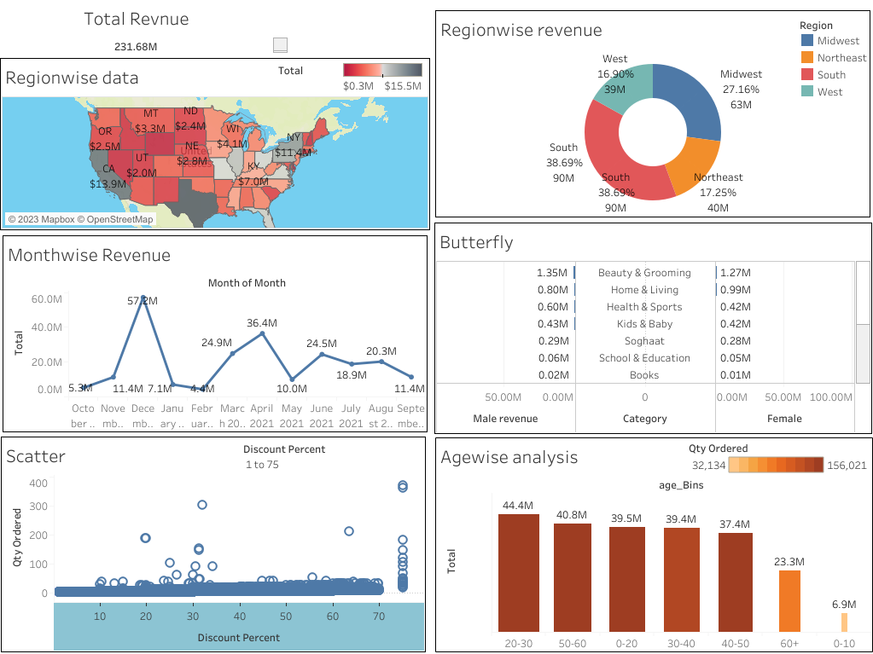

https://public.tableau.com/app/profile/kapil.agrawal1413/viz/AirlinesPricePredictionAnalysis/Dashboard1